# Genesis December 2017

* **Christmas Festival**

On December 19 we participated in an evangelistic Christmas festival in Cecara with the objective to knowing the true meaning of Christmas, and sharing the good news of salvation.

There were various presentations such as a re-enactment of the Christmas story, dramas, poems, dances and a Christmas chorus.

Through this activity we were able to reach about 80 different children, youth and adults.

We give thanks to the Lord for this blessed time, where we celebrated the birth of Jesus, and we were able to do it with participation from our community.

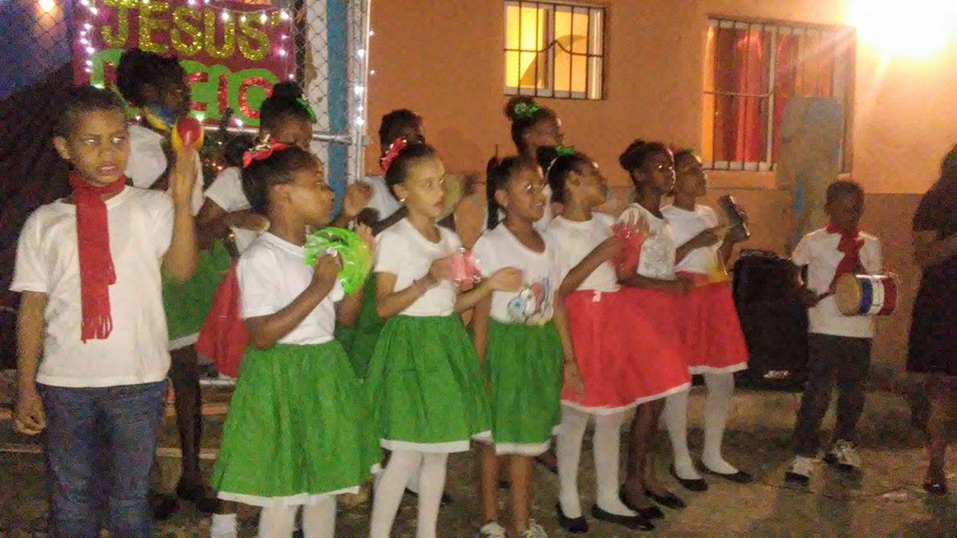

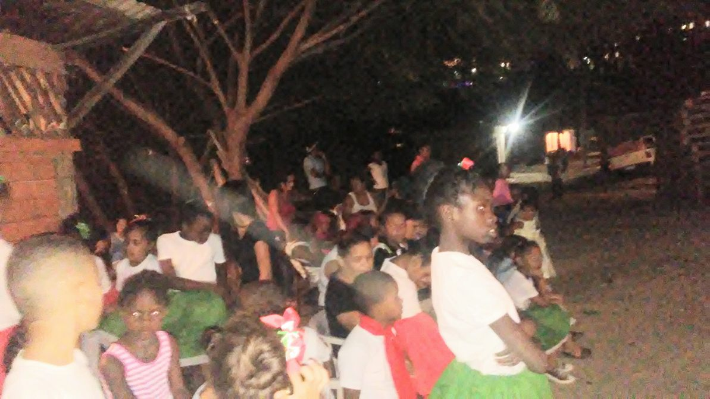

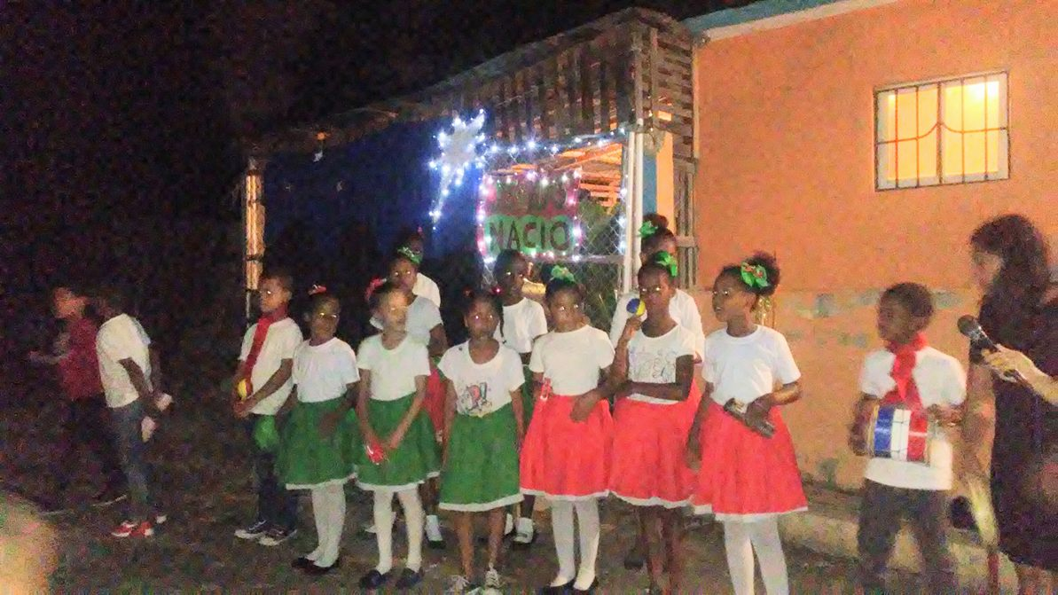

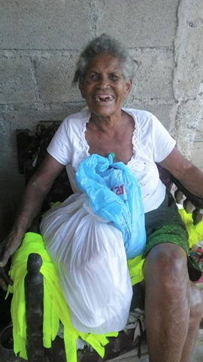

On December 24, the members of the Banegas church practiced what they had been learning during the month about compassion as a lifestyle.

We went to some of the needy families in our community, who because of their poverty would not be able to have a Christmas dinner. Ten different families were surprised to see this special blessing arrive to their homes.

We shared the word of God with each family and prayed for their needs.

We know that through this, they were able to know the love of God, as well as his care for them.

* **Christmas Dinner (Compassion)**

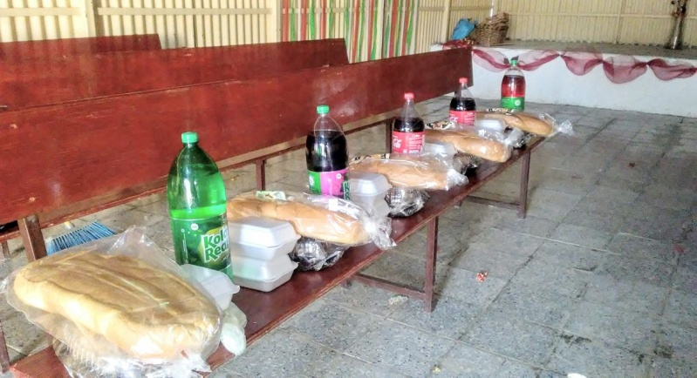

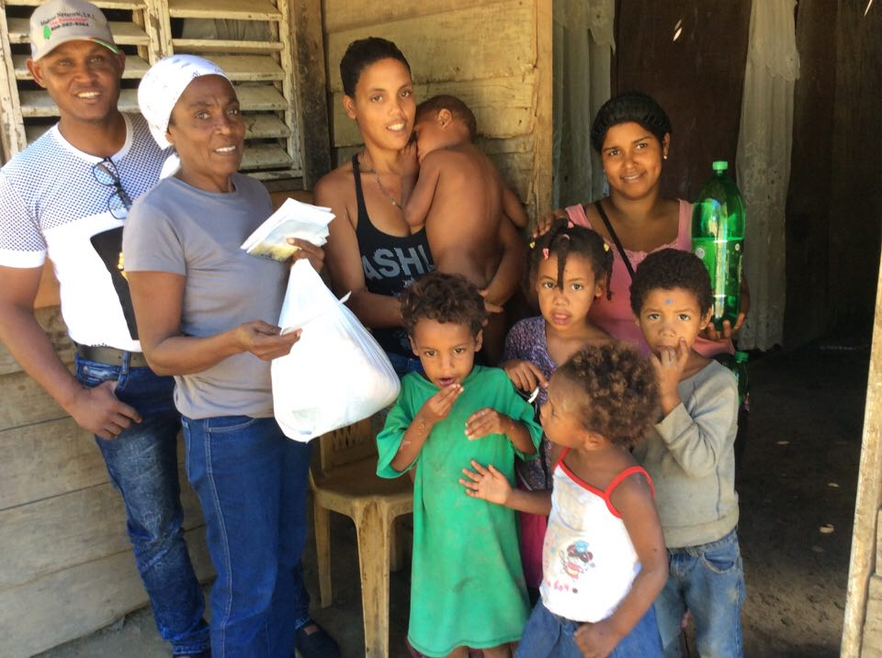

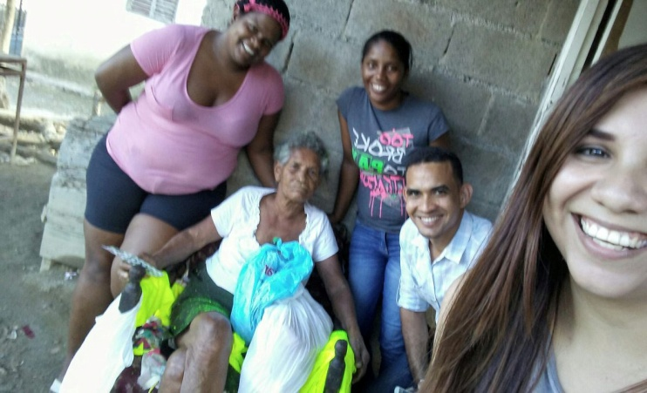

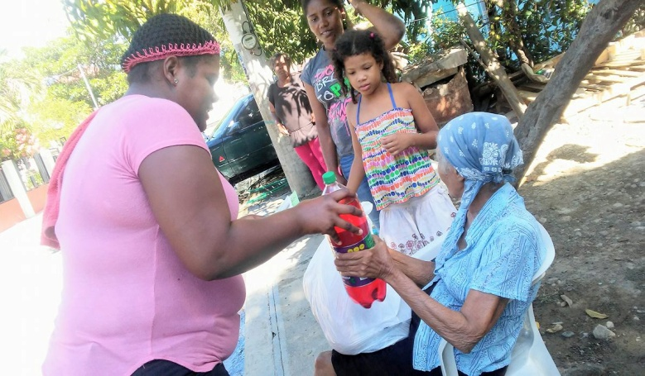

* **Study Kits**

On December 23, we had a Christmas celebration where we were able to gift study kits to our members, with the purpose of strengthening the devotional life of each disciple.

