

Mobilization

Mission Corps Handbook





Introduction 3
A. Mission Corps Classifications 4
Long-Term Mission Corps 4
Tentmaker 5
Short-term Mission Corps 5
B. Placement Process 7
C. Responsibility 9
Participant’s Responsibility 9
Global & Regional Mission Personnel Office Responsibility 9
Field Office Responsibility 10
D. Assignment Expecation. 11
Risk . 11
Accountability . 11
Conduct 11
All Other Matters 13
E. Convenant of Christian Character 14
F. Finance 15
G. Raising Support & Contributions 17
How to Submit Contributions 17
Refunds and Reimbursments. 17
How Support Funds are Processed . 18
Reporting Expenditures for a Local Nazarene Church to Receive 10% Credit . 18
H. Insurance . 19
Guidlelines . 19
Rates . 19
Coverage and Exclusion. 19
Required Forms and Information . 20
Submitting a Claim . 20
Medical Evacuation . 21
Contact Information . 21
I. Forms . 22
J. Helpful Information . 28

Introduction

As people go to announce and embody the Good News, they are fulfilling what Jesus promised: His Spirit would come upon the Church and His people would be witnesses to the world. God’s promise of mission precedes the actual ministry of the Church, so when people do engage the world in Jesus’ name they are fulfilling God’s promise and affirming the ultimate purposes of God.

A Sent Church
“As the Father sent me,” Jesus tells all of His disciples, “so I send you.” The Scriptures describe how the whole Church is sent to the world. By nature the Church is Missional. Wherever it exists, the Body of Christ has been sent to that specific community to reveal the will and purposes of God.

Within the Body, there are some individuals whom God leads towards cross-cultural ministry beyond the local church. The Church of the Nazarene affirms and celebrates such a leading of the Spirit, and those people are sent as missionaries to places and cultures distinctly different from their own.

A Sending Church
Global Mission has been designated by the Church of the Nazarene to administer this form of missionary sending. The Mission Corps Handbook is crafted in order to assist the Mission Corps Participant by providing a description of how to operate in their missionary assignments. The handbook is not meant to be an exhaustive document. Every assignment is unique due to its setting, the unanticipated challenges, and opportunities that present themselves. Consequently, it is impossible to anticipate and address every potential circumstance missionaries will face. Nevertheless, it is desirable to create clarity regarding common issues they face as they serve Christ in the world through the Church of the Nazarene. If there are any questions regarding the content or the practices described in the handbook, please contact the appropriate field or regional leadership.

- Mission Corps Classification

Mission Corps is a ministry that enables people to serve with the Church of the Nazarene. There are opportunities to serve in all the regions of the world. Information on these opportunities is available through the Mobilization Office, Nazarene websites, Nazarene schools, missionaries, local churches and districts. Mission Corps participants primarily raise their own support for the ministry they are involved in. Anyone interested in serving through Mission Corps with the Church of the Nazarene will belong in one of the following categories: long-term, tentmaker, or short-term.

Classifications

1. Long-Term Mission Corps Requirements: (91 days or more)

- Completing an Exploring Missions Form (EMF) and Completed References
- Attending a Cross-Cultural Orientation
- Field and Region Approvals
- Cleared Background Check and Completion of Ministry Safe training.
- Signed Mission Corps Agreement and Financial Understanding
- Insurance

A completed Exploring Missions Form is required for everyone who serves long-term with the Church of the Nazarene. An EMF is available online at: https://secure.nazarene.org/EMFonline/.

Attendance at a Cross-Cultural Orientation (CCO) is required to serve through Mission Corps. It is an important time of training and evaluation for those interested in serving internationally. CCOs are scheduled in various locations throughout the year. You can visit www.missioncorps.org and select “Cross-Cultural Orientation” to view the current schedule and register for an event.

Long-term Mission Corps participants must receive approval from the Field Strategy Coordinator (FSC) and the Regional Director (RD). This approval may be included in a person-specific Personnel Request Form (PRF) or, if a PRF is already on file, through an e-mail confirmation.

Once approvals are received for the Mission Corps Participant they must also sign off on receiving a background check. The Mobilization office will request a background check for the participants. Each Mission Corps participant must also watch the Ministry Safe Training Videos and complete the quiz. The Mobilization Office will send a link to complete this training.

Once an assignment is accepted, the Mission Personnel Office will issue long-term Mission Corps participants two documents prior to departure for the field: a Mission Corps Agreement and a Financial Understanding. These documents are electronic and will come via DocuSign. The Mission Corps Agreement deals with personal conduct while serving and accountability. The Financial Understanding, which is based on the Financial Information Form (FIF), provides details on the dates of service and financial responsibilities.

Insurance is necessary for the protection of the participant and the field. It is required for long-term participants and can either be paid up front or deducted from raised support funds.

Long-term Mission Corps participants are a vital part of ministry to the field and region. They are included in the General Secretary’s Annual Report and added into the number of missionaries serving with the Church of the Nazarene.

2. Tentmaker Requirements:

- Completing an Exploring Missions Form (EMF) and Completed References
- Attending a Cross-Cultural Orientation
- Field and Region Approvals
- Cleared Background Check and Completion of Ministry Safe training.
- Signed Mission Corps Agreement and Financial Understanding
- Insurance (unless provided by employer)

Tentmakers are Mission Corps participants whose secular vocation leads them to a different culture or allows them creative access to a "closed" world area. Their job provides support while they coordinate their spare time to help the local church and missionaries accomplish their goals. Generally the requirements for Tentmaker Mission Corps participants are the same as long-term Mission Corps Participants. However insurance may be provided by the participant’s employment in which case only the liability portion of the insurance would need to be purchased.

3. Short-Term Mission Corps Requirements: (90 days or less)

- Field and Region Approvals
- Insurance

Individuals who serve short-term are encouraged to complete an EMF and to attend a CCO. While not required, the field or region may ask a short-term Mission Corps participant to fill out an EMF and to attend a CCO. They may also request that a Mission Corps Agreement and a Financial Understanding be issued to clarify the assignment.

Field and Regional approval are required for Short-Term Mission Corps participants. This can be obtained via email.

Insurance is necessary for the protection of the participant and the field. It is required for short-term participants and it will need to be obtained and paid for prior to departure.

Exceptions to Length of Service: There may be a special need on the field that would permit a short-term participant to serve slightly longer than 90 days but still not necessitate them to fulfill the requirements listed for Long-Term Mission Corps participants. In those special situations, the EMF and CCO requirements can be waived at the request of the Field and Region.

B. Placement Process

- A participant who serves within their region of nationality will be processed by the appropriate Regional Personnel Coordinator (RPC) according to established Regional Guidelines. The FSC and the RD will give approval to both the assignment and the participant.

- A participant who goes from one region to serve on another region will need the recommendation of the sending Field and Region and the approval of the receiving FSC and RD. The Global Personnel Office will help to facilitate the finalization of the assignment.

- The field or institution of any world area should identify personnel needs and submit an online Personnel Request Form (PRF) to the responsible FSC. If approved, the request will then go to the RD for approval. Once the FSC and the RD have approved the request it will be posted “live” to the website.

- The PRF is important because it gives relevant information to potential participants who are in the placement process. It insures that all the necessary approvals have been granted. It also gives the details of the assignment so the participant and the field can evaluate whether the position is right for both parties.

- The Financial Information Form (FIF) is used to verify the amount of support funds that are needed for a particular assignment. The FIF helps enable potential participants to know what the cost of a ministry assignment will be in a particular location. The FIF also states how much needs to be raised prior to purchasing tickets to go to the field. Whoever submits or completes the PRF is also responsible for completing the FIF.

- The appropriate Personnel Office presents the profiles of potential long-term personnel to the FSC & RPC in order to fill current Personnel Requests. The FSC, in consultation with field personnel, determines where potential personnel will best fit and approves the acceptance and placement of the participant. The FSC communicates Field approval to the Region.

- If the participant can fill a different need that is not posted but fits into the mission strategy of the Field or Region then the FSC will prepare a new PRF and FIF and obtain the necessary approvals.

- The appropriate Personnel Office, in cooperation with the Global Personnel Office, deploys participants by securing approvals, facilitating insurance coverage, directing the flow of support money to the assigned ministry location and preparing a Mission Corps Agreement and Financial Understanding that will be signed by the long-term participant.

C. Responsibility

Nazarene Global and Regional Personnel offices are working together under the guidance of the Global Mission Director to coordinate the sending of personnel who sense God leading them to go and “Make Christ-like Disciples in the Nations.” Mobilization is part of the Global and Regional Personnel Offices. Together with Field Offices; they work in partnership to facilitate all Mission Corps assignments.

  - Participant’s Responsibilities:
    - Provide personal profile information and reference information through completing an Exploring Missions Form.
    - Assess personal readiness for service by evaluating:
      - A sense of God’s Direction
      - A developing role in cross-cultural ministry.
      - A skill set(s) that will benefit the local mission strategy of the field.
      - A growing spiritual maturity.
      - A developing prayer support base.
      - A growing understanding of financial responsibility and management.
    - Communicate with the appropriate Personnel offices about a possible assignment.
    - Establish a timeline for service and communicate potential itinerary with the appropriate Personnel Office.
    - Create a support base for both prayer support and raising funds.
    - Sign off on a Background Check and Complete the Ministry Safe Training.
    - Research and obtain appropriate VISA/permits.
    - Fulfill ministry role to the best of their abilities and communicate with appropriate local and field leadership if problems arise.
    - Follow the Mission Corps Handbook.
    - Complete a Ministry Evaluation.

  - Global and Regional Mission Personnel Office Responsibilities:
    - Provide information to those who are interested in mission involvement.
    - Work with a potential participant to communicate steps toward serving.
    - Complete the Background Check and follow up with the references.
    - Assess and communicate regarding a potential participant’s readiness for service.
    - Connect a potential participant to global needs.
    - Finalize assignment details between a potential participant and the Field and Region, including the appropriate approvals.
    - As needed, give support and assistance once a mission participant is on-site.
    - Express gratitude to a mission participant upon their return home.
    - Evaluate their mission experience and effectiveness. Dialogue with a mission participant concerning their call to future involvement.
    - Encourage the mission participant to follow God’s call on their life.

  - Field Office Responsibilities:
    - Receive a potential participant’s information from the appropriate Personnel Office.
    - Communicate with a potential participant about a possible assignment.
    - Assess a potential participant’s ability to meet the need on the field.
    - Work with the appropriate Personnel Office to finalize assignment details.
    - Receive a mission participant on the field.
    - Give field orientation (formal or informal) to help a mission participant adjust to the culture and work environment.
    - Support a mission participant during their time on the field.
    - Manage support funds with the mission participant.
    - Communicate with the appropriate Personnel Office any changes to assignment (location, length of stay, etc.).
    - Complete a Ministry Evaluation.
    - Express gratitude to a mission participant while serving and upon their return home.
    - Encourage the mission participant to follow God’s call on their life.

D. Assignment Expectations

- Risk - Understanding that there is potential suffering and hardship associated with participation in a cross-cultural ministry assignment, all Mission Corps participants willingly choose to engage in cross-cultural ministry. The Mission Corps participant does and will assume all risks of damage to and loss of personal property, as well as the possibility of personal injury or loss of life and agrees not to hold the church, its employees, or agents liable.

- Accountability - Mission Corps participants shall communicate through the appropriate lines of accountability. He or she shall communicate any questions, suggestions or concerns to the person to whom he or she is accountable. If the subject matter, or the nature of the relationship, makes it exceptionally difficult to discuss with the person they are accountable to, then the Mission Corps participant may speak directly with the individual who gives leadership to that person. Typically issues should be addressed first with the person they are responsible to then their FSC.

- Conduct - It is expected that all Mission Corps participants will exhibit a Christ-like lifestyle. He or she shall evidence the life of the Spirit.
  - Christian Behavior - All Mission Corps participants shall abide by the Covenant of Christian Character (see page 14 of the Handbook) and consistently meet for worship with a specific congregation selected in consultation with the person to whom they are accountable.
  - Relationships - All Mission Corps participants shall observe the highest standards of purity in relationships. He or she will always be careful to live in a way that is appropriate and inoffensive within the cultural context where they serve.
    - Dating – Dating in cross-cultural settings is often subject to misunderstandings. Consequently, a Mission Corps participant may date someone in his or her place of service only after first securing written permission from the FSC & RPC in consultation with local leadership.
    - Extended Absence from Family - Global Mission highly values family life and recognizes the strain put on family relationships by extensive absences. Therefore, a Mission Corps participant will not be separated from his or her immediate family for more than 21 consecutive days without the written approval of the RD. For absences in excess of 35 days, the Global Mission Director must also give approval.

  - Rest - A Mission Corps participant shall observe times of Sabbath/Rest. The nature of the ministry may require him or her to be flexible as to when he or she rests. However, generally speaking, it is necessary to find the equivalent of one day of rest each week.
  - Peace and Politics - All Mission Corps participants shall be peace makers; both with individuals around them and in the society in which they serve. He or she will obey all civil laws applicable and may only participate in the political matters of the place where he or she is serving after obtaining written permission from the FSC.
  - Employment - All Mission Corps participants shall devote their time and energy to the ministry for which they were sent. He or she may become engaged in external employment, or assume responsibilities beyond the scope of the Church of the Nazarene, if he or she has first obtained written permission from the FSC.
  - Travel - All Mission Corps participants shall secure written permission from the local leadership, FSC, and RPC before traveling outside the assigned area of service. The appropriate Personnel Office should be notified for insurance and safety purposes.
    - Personal Travel/Vacation – The Mission Corps Participant must receive approval for personal travel as well as ministry related travel. Ministry funds cannot be used for personal travel. Any vacation time must be approved by their FSC & RPC.
  - Guests - All personnel sent through Mission Corps shall obtain written permission from the FSC before inviting guests from outside their country of assignment to visit them. Once the FSC approves, they shall request Regional Approval. All such guests to the field must be insured (see the necessary terms of insurance under “Insurance” guidelines, pages 19-21).
  - Debt - All Mission Corps participants may only contract debt on behalf of the Church of the Nazarene after obtaining written approval from the FSC. At no time should a Mission Corps participant incur any personal debts to people or organizations located in the place in which he or she ministers.
  - Ministry Review and Evaluation -All long-term Mission Corps shall participate in a Ministry Review at the end of the term of service. For those who will serve for more than one year, this evaluation will take place at the end of each agreement. Prior to a new agreement being issued the evaluation by the Field and Mission Corps Participant must be completed.
  - Termination of Agreement - All personnel sent through Mission Corps may have their service terminated at any time at the option of either the church or the participant, with or without cause, and with or without prior notice. Mission Corps participants returning home shall pay for the related expenses from their ministry funds, unless otherwise noted.
  - Transferring Regions – At times a Mission Corps participant may transfer from one region to another region for a new assignment. In these cases the Mission Corps participant will work in conjunction with the two regions regarding the potential transfer of funds and ministry equipment. If the Region and Field approves and ministry equipment is sold the funds from that sale must be re-deposited into the ministry account for their new assignment or remain on the field.
  - Completion of Agreement - At the end of service, a Mission Corps participant shall deliver all money, accounts, books, records, equipment (including anything purchased with ministry funds), and all property which belongs to the Church of the Nazarene to the person to whom he or she is accountable.

- All other matters - For all matters and issues not covered in the Mission Corps Handbook please speak with your FSC and RPC on how to proceed regarding these matters.
E. Covenant of Christian Character

- To be identified with the visible Church is the blessed privilege and sacred duty of all who are saved from their sins and are seeking completeness in Jesus Christ. It is required of all who desire to unite with the Church of the Nazarene, and thus to walk in fellowship with us, that they shall show evidence of their salvation from their sins by a godly walk and vital piety; and that they shall be, or earnestly desire to be, cleansed from all indwelling sin. They shall evidence their commitment to God—
  - FIRST, By doing that which is enjoined in the Word of God, which is our rule of both faith and practice, including:
    - Loving God with all the heart, soul, mind, and strength, and one’s neighbor as oneself.
    - Pressing upon the attention of the unsaved the claims of the gospel, inviting them to the house of the Lord, and trying to compass their salvation.
    - Being courteous to all men.
    - Being helpful to those who are also of the faith, in love forbearing one another.
    - Seeking to do good to the bodies and souls of men; feeding the hungry, clothing the naked, visiting the sick and imprisoned, and ministering to the needy, as opportunity and ability are given.
    - Contributing to the support of the ministry and the church and its work in tithes and offerings.
    - Attending faithfully all the ordinances of God, and the means of grace, including public worship of God, the ministry of the Word, the sacrament of the Lord’s Supper; search the Scriptures and meditating thereon; family and private devotions.
  - SECOND, By avoiding evil of every kind, including:
    - Taking the name of God in vain.
    - Profaning the Lord’s Day by participation in unnecessary secular activities, thereby indulging in practices that deny its sanctity.
    - Sexual immorality, such as premarital or extramarital relations, perversion in any form, or looseness and impropriety in conduct.
    - Habits or practices known to be destructive of physical and mental well-being. Christians are to regard themselves as temples of the Holy Spirit.
    - Quarreling, returning evil for evil, gossiping, slandering, spreading surmises injurious to the good names of others.
    - Dishonesty, taking advantage in buying and selling, bearing false witness, and like works of darkness.
    - The indulging of pride in dress or behavior. Our people are to dress with the Christian simplicity and modesty that become holiness.
    - Music, literature, and entertainments that dishonor God.
  - THIRD, By abiding in hearty fellowship with the church, not inveighing against but wholly committed to its doctrines and usages and actively involved in its continuing witness and outreach.

[For a record of the Covenant of Christian Character, which includes Scriptural citations, see the Manual of the Church of the Nazarene Part II, “The Church,” Section V, paragraphs 27-27.3]

F. Finance

- All Mission Corps participants shall practice integrity in financial matters; especially in regards to raising and using support funds. When support funds are used wisely they make possible the work and ministry of the Church. A Mission Corps participant shall follow the provisions made in the Manual (page 102, section R., paragraph 156) of the Church of the Nazarene for raising financial support for his or her ministry. Support is generated through their personal financial resources, ministry partners such as family, friends, colleagues, and local churches.

- Support funds raised by Mission Corps participants are either charitable donations or personal gifts. They are not considered “deputation” funds since those serving through Mission Corps are not employees of the denomination.

- All support funds that are raised for a Mission Corps ministry assignment and processed through the Global Treasury Services (GTS) office are designated ministry funds and are not personal funds. Funds processed through GTS will be sent to the field once a month via the allocation system. All contributions must be received by the GTS office on or before the 25th of any given month to insure that they will be sent to the field the following month. Any funds received after the 25th may be sent to the field in the next available allocation which could incur a delay of two months. For example: Funds received on or before July 25th are sent in the August allocation; funds received on or after July 26th may be delayed until the September allocation. Funds that are received and processed by the GTS office before deployment will be sent to the field and held for the Mission Corps ministry assignment.

The monthly and total costs expected for the ministry assignment will be outlined in the Financial Information Form (FIF), which is provided by the field and region. The FIF is used to prepare the Financial Understanding that is signed when accepting an assignment. Approved Mission Corps participants need to have a minimum of 50% of support funds raised and processed for their assignment before purchasing plane to tickets to travel to their ministry location.

- The IRS of the U.S. allows support funds to be donated to Mission Corps ministry. These donations are eligible for a charitable contribution receipt that can be issued either by the GTS office or the local church, depending on who receives and processes the support funds. They are not considered income for the Mission Corps Participant. The Mission Corps Participant will work their Field and Regional leadership in setting up a Per Diem/Allowance for monthly expenses. The expenses that can be included in that ministry funds can be used for include these categories:

  - Food
  - Housing
  - Utilities
  - Transportation (to and from the field and on-site ministry travel)
  - Insurance
  - Vaccinations
  - Visa/Passports
  - Language Study (requires site-specific approval)
  - Ministry Equipment (requires site-specific approval)

    - Eligible ministry expenses would fall under the same classification as a “business” expense.
    - Some expenses will be covered by the Per Diem and others will be reimbursable expenses. The Mission Corps Participant will work with the Field and Region in setting this up.

- After deployment, the Field will develop a PerDiem/monthly support plan according to the amounts stipulated for ministry expenses on the FIF. The Field Strategy Coordinator must approve any deviations from the stipulated amounts as needed.

- Approved Mission Corps participants are responsible to keep accurate financial records of support funds that are advanced to them. They should keep track of their reimbursed ministry expenses to help to facilitate the monthly accounting of support funds. Anytime a request is made for reimbursement there must be a receipt. Due to IRS regulations, every effort should be made to get a receipt for any one item that costs more than $75.00.

- The Field may make any necessary deductions, in consultation with the Mission Corps participant, for expenses that have been disbursed to their ministry account according to the amounts stipulated on the FIF before advancing support funds.

- At times the Global Mission Personnel Office will debit support funds when a request for reimbursement of expenses is received from approved Mission Corps participants prior to their arrival on the field. Sufficient funds must be available to process a reimbursement.

- Insurance payments for Long-Term participants can be deducted monthly from the field allocation by the Global Treasury Services office unless the insurance premiums are paid in advance. These deductions will be reimbursed to the Field by debiting the support funds or by direct payment of the participant. Short-Term participants must pay the insurance premium in advance of their trip.

- When approved participants return home, any excess support funds shall be held on the field for at least 60 days to cover reimbursable expenses. Participants may request reimbursement for eligible expenses if there are sufficient funds available in the remaining support funds on the field. After 60 days, the FSC, RPC & RD, in consultation with the participant, may re-direct funds to another ministry on the field.
  - If the individual is returning to the same field, excess funds may be held for them. If the individual transfers or is deployed to a new field, funds may be transferred after consultation with the FSC, RPC, and RD.
  - Personal Gifts for Approved Mission Corps participants should be facilitated through a local financial system (i.e. deposited by family and friends to a personal checking account, debit account, etc.) and used as he or she sees fit.

G. Raising Support & Contributions

- How to Submit Contributions for Support Funds
  - Once a Mission Corps Participant has Regional and Field approval then they may began fund raising for their ministry time.
  - Charitable donations sent to the Global Treasury Services office for Mission Corps ministry expenses should be made payable to General Treasurer Church of the Nazarene, and sent to:
Church of the Nazarene, P.O. Box 843116, Kansas City, MO 64184.
Each donation should be clearly marked with:
    - Location of Assignment
    - Name of Participant (i.e. Last Name, First Name) and
    - Name of Approved Program (i.e. Mission Corps)
      - Without these three pieces of information, GTS cannot ensure that a donation will be properly routed. (example: “Costa Rica” – Williams, Jamie – Mission Corps”)
  - Individual donors should give through their local Nazarene church if they want their church to receive 10% Mission Giving Recognition. Only support funds processed through GTS or reported to GTS via a Remittance Form from the local church are eligible for the 10% Mission Giving Recognition. Each local church has a remittance form that the GTS office has provided to them. Please be sure to have the local treasurer include the three items of information listed above for proper routing. A copy of a remittance form is at: www.missioncorps.org/Resources.

- Refunds and Reimbursements of Support Funds
  - Per IRS regulations, refunds of donated Mission Corps support funds are not allowed once a local church or the GTS office issues a charitable contribution receipt. If a participant does not go to the field, or returns home early, or has excess support funds left on the field, the FSC, RPC, & RD in consultation with the participant, can redirect the funds to another Nazarene ministry.
  - If a participant incurs ministry-related expenses and wants reimbursement from the Global Mission Personnel Office or the Field Treasurer from contributions made to Mission Corps, the following requirements must be met:
    - The individual has sufficient donated support funds available.
    - The individual submits a written request to the Global Mission Personnel Office or the Field Treasurer where they are serving.
    - The individual submits a copy of the original receipt that shows the amount of the bill that is being reimbursed.
  - Reimbursements will only be made for total amounts in excess of $100.
  - Personal expenses are not eligible for reimbursement from support funds.

- How Support Funds are Processed
  - Funds will be sent directly to the field through the allocation system once an assignment has been approved.
  - You may call the Mobilization Office at 913-577-0500 with any questions.
  - The Mission Corps Participant can receive a monthly fund report showing the amount that has been sent in and processed for their ministry fund.

- Reporting Expenditures for a Local Nazarene Church to Receive 10% Credit
  - If an individual or a local Nazarene church incurs ministry expenses for a Mission Corps participant, these expenses can receive 10% Mission Giving Recognition. To receive credit, a local Nazarene church, must report the expenditures on the church’s local Remittance Form as ministry expenses. The form must be sent to GTS.

H. Insurance

- Guidelines
  - Every Mission Corps participant or guest must be insured. This is for the protection of the Individual, Field, Region and the General Board of the Church of the Nazarene.
  - Insurance is available for purchase through AXIS, and is facilitated by the Global Mission Personnel Office.
  - If a Mission Corps participant thinks that their current insurance policy meets all of the requirements listed below, their policy must be submitted to the appropriate Mission Personnel Office at least 60 days before departure so that it can be reviewed to verify coverage. The General Board required portions and corresponding benefit amounts of your policy must be highlighted with a color marker for the reviewing process.
    - If the policy qualifies, the Mission Corps participant will still be responsible for the International Liability portion of the Mission Corps insurance policy at $ .30 per day/per person as required by the General Board.
  - Policy Benefits:
    - Accident and Sickness Medical Expenses ($100,000) - $100 deductible per claim
    - Accidental Death and Dismemberment ($75,000)
    - Emergency Medical Evacuation (100% of Usual and Customary Charges)
    - Repatriation of Mortal Remains (100% of Usual and Customary Charges)
    - Security Evacuation (100% of Usual and Customary Charges)
    - International Liability (required for every Mission Corps participant and/or guest.

Before deployment, each Mission Corps participant or guest must complete the online Global Mission Insurance Form. This can be found at: https://gminsurance.nazarene.org/gminsurance/missioncorps.xhtml.

- Rates
  - Insurance premiums will be deducted automatically from the field unless paid in advance by the Mission Corps participant or guest.
  - The field is responsible for collecting the monthly premiums from the Mission Corps participant or guest or deducting the monthly premiums from their support funds.
  - The insurance premium costs* are as follows:
If you are on the field for 1 - 21 days – US $3.25 per day/per person
If you are on the field for 22- 90 days – US $2.75 per day/per person
If you are on the field for 91-365 days – US $2.25 per day/per person
*Rates are subject to change so check the website for the current costs.
- Coverage and Exclusion Limitations
  - The insurance provided through AXIS has a $100 deductible per incident and no co-pay. After the deductible, the plan will pay 100% up to the maximum amount stated.
  - This insurance is not a Major-Medical policy.
  - All expenses need to be cared for by the Mission Corps participant or guest prior to submitting a claim to AXIS through the Global Mission Personnel office.
  - AXIS will process the Claim Form with accompanying receipts and reimburse the Mission Corps participant and/or guest based on the policy.
  - Several medical exclusions are listed (pre-existing conditions are covered at a lower benefit). Please make sure to read through the Global Insurance Brochure (www.missioncorps.org/Resources - “Insurance” heading) for more detailed information.
  - AXIS Insurance does not cover:

    - Routine Physicals
    - Routine dental care and treatment
    - Cosmetic or plastic surgery
    - Child Care
    - Eye Refractions or examinations
    - Mountain Climbing
    - Travel for medical care or treatment
    - Hearing Aids
    - Worker’s comp
    - Any mental nervous disorders or rest cures
    - Skiing
    - Sky diving/Scuba diving
    - Any injuries directly caused by an act of war are not covered.

- Required Forms and Information
  - Each Mission Corps participant or guest must complete a “Global Insurance Form” and submit it to the Global Mission Personnel Office. There is also an option to complete a web form and pay online with a credit card.
  - When figuring the number of days of insurance coverage needed, be sure to count the first day of travel and the ending day of travel so that each Mission Corps participant or guest will be insured while they travel to and from the field.
  - The “Accident & Sickness Claim Form” and the “Global Insurance Brochure” should be taken to the field with the participant or guest. These forms can be downloaded from the website.
  - All the forms and the brochure are available at: www.missioncorps.org/Resources under the “Insurance” heading, toward the middle of the page.

- Submitting a Claim
  - If a Mission Corps participant or guest starts to exhibit symptoms of an illness, they need to be seen by a physician or local healthcare provider prior to leaving the field. The attending physician will need to fill out and sign their portion of the Accident & Sickness Claim Form.
  - The Mission Corps participant or guest will also need to fill out and sign their portion of the Accident & Sickness Claim Form. This form must be submitted to the Global Mission Personnel Office with the corresponding receipts in order for the insurance company to process the claim.
  - Written notice of a claim must be submitted to the Global Mission Personnel Office as soon as possible so that the insurance company can be notified. One Accident & Sickness Claim Form is needed for each accident and/or sickness or the claim cannot be processed.
  - The insurance company will cover continued treatment back in the home country if the Mission Corps participant or guest was seen by a physician prior to leaving the field where they were serving or visiting. This continued coverage is available for up to 365 days from the date of the incident/sickness.

- Medical Evacuation
  - If at any time an individual needs medical evacuation, security evacuation or repatriation, the insurance company (AXIS) must be contacted before any arrangements are made. The number to use when outside the US is: 001.609.375.9190 (Call Collect).
  - Then immediately contact the Global Mission Personnel Office at: 001-913-577-2953.
  - For emergency contact during evenings and weekends use: 001-816-699-5420.
  - If you opt to make your own arrangements, all costs will be your personal responsibility.

- Contact Information – If you have questions concerning signing up for insurance or policy information please contact Duane Baty 913-577-2961 or dbaty@nazarene.org if you have a claim please contact Krista Block 913-577-2953 or kblock@nazarene.org.

I. Forms
Mission Corps Agreement
We, _______________, acknowledge Jesus Christ as Lord and Savior and declare that our primary intention is to make Christ-like disciples, to establish and develop Nazarene churches, and to cooperate with local, district, and field leadership.

We affirm the message and mission of the Church of the Nazarene and fully support the Articles of Faith as found in the Manual of the Church of the Nazarene.

We have received the Mission Corps Handbook, have read and agree to follow and abide by the policies that are stated therein.
Initial Here: ________ Initial Here: __________

We understand that, while serving, we are required to abide by the Covenant of Christian Character (Manual of the Church of the Nazarene, paragraphs 27-27.3).

We agree to the following:

- To make disciples.

- To give ourselves diligently to understand the culture and language of the people with whom we work.

- To commit ourselves to excellence in service and to high ethical standards, to live in a manner sensitive to the culture of residence, to protect the image and reputation of the Church of the Nazarene, and to bring glory to God in everything we do.

- To communicate systematically and appropriately with our home church and friends in order to maintain informed prayer and financial support.

- To cooperate with the General Board of the Church of the Nazarene and its representatives and to be accountable to ___________________ as our supervisors as designated by the field or region of service, in matters related to our assignment.

- To raise the necessary funds required for the assignment as outlined in the Financial Understanding form.

We understand that, at the option of either the Church or ourselves, our service can be terminated at any time, with or without cause, and with or without prior notice.

This agreement is in effect from the date of ______________ to ______________.

Signed: _______________________________________________ Date:

Signed: _______________________________________________ Date:

Financial Understanding
As you prepare to serve as a missionary through Mission Corps, please be aware of the following items.

I. The missionary agrees to provide through support funds (donations) or platform income:
- Round trip travel to the Field
- Visa expense
- Housing
- Utilities
- Food
- On-site Travel (Ministry and ‘Non-Leisure’ Only)
- Insurance

II. The missionary agrees to provide through personal funds or platform income:
- Other Personal Living Expenses such as: vacations, toiletries, children’s education, clothing, medical, dental, and retirement expenses or other items not eligible for reimbursement as a Business Expense.

III. The Field/Region agrees to provide:
- A system for financial accountability in accordance with tax guidelines.
- A method for conveying donated funds to the missionary as reimbursements for qualifying expenses.
- Equipping and Prayer support and an opportunity for the missionary to fulfill their calling

This Financial Understanding is in effect from the date of ______________ to _______________.

SIGNATURE:________________________________________ DATE:________________

SIGNATURE:________________________________________ DATE:________________

Sample Support Letter
Date

Dear (FAMILY /FRIENDS):

I would like to share with you an exciting opportunity that God has opened up for me. I have been approved by the Church of the Nazarene, Global Mission Office, to serve as a Mission Corps participant in COUNTRY for a period of LENGTH OF ASSIGNMENT. I will be DESCRIPTION OF MINISTRY ASSIGNMENT.

[Describe your future ministry and country of service in a paragraph.]

I believe that ministry is best done through community, and that you can be a part of this ministry that touches lives around the world. Please consider supporting me as a prayer partner in this ministry. Please ask that God would prepare my heart and provide for my needs. Also pray that God would bless the people with whom I will be serving and that God would use me to further his Kingdom in that place.

The World Evangelism Fund has provided a base for my service through the generous giving of people like you (i.e. support for the local missionary, leadership and district development). In addition, to serve in this ministry for LENGTH OF TIME I will need to raise AMOUNT. The cost includes travel expenses, housing, utilities, food, and insurance. I would enjoy the opportunity to talk with you about this upcoming ministry and answer any questions you might have.

Should you choose to give financially to help support this ministry, here are the details you will need to know. Checks should be made out to: General Treasurer, Church of the Nazarene. All checks should be mailed to: PROVIDE THE ADDRESS OF GLOBAL TREASURY SERVICES OR YOUR LOCAL CHURCH DEPENDING ON HOW YOU HAVE SET UP THE FLOW OF YOUR SUPPORT FUNDS. Please include MY NAME/”MISSION CORPS”/COUNTRY on the memo line of your check in order for the funds to go to the appropriate area of the world where I will be serving.

In addition, I will have personal expenses that are not eligible for a charitable tax receipt. If you wish to help with those expenses, you can send the donation to: PROVIDE THE ADDRESS. Remember, if you send funds directly to me, you will not be eligible for a tax deduction.

Thank you for your thoughtful prayers and support. I am grateful for the opportunity the Lord has given me to serve Him in COUNTRY.

Yours truly,

Remittance Form
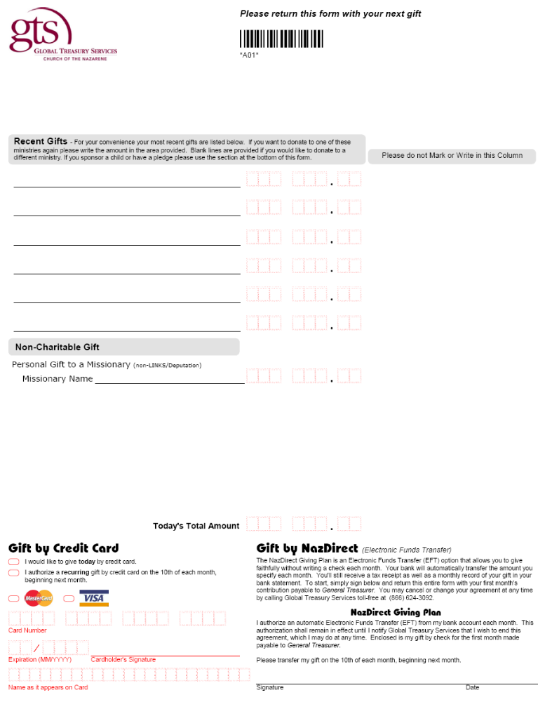
- AXIS Insurance Card

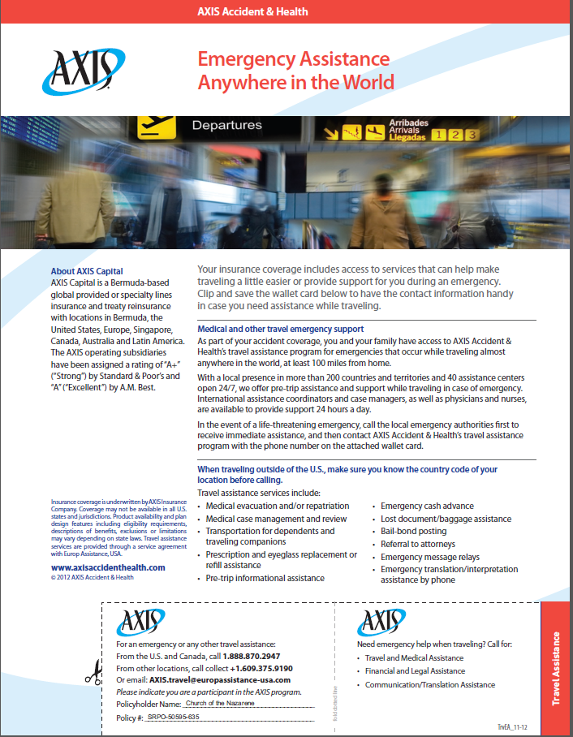

Axis Claim Form

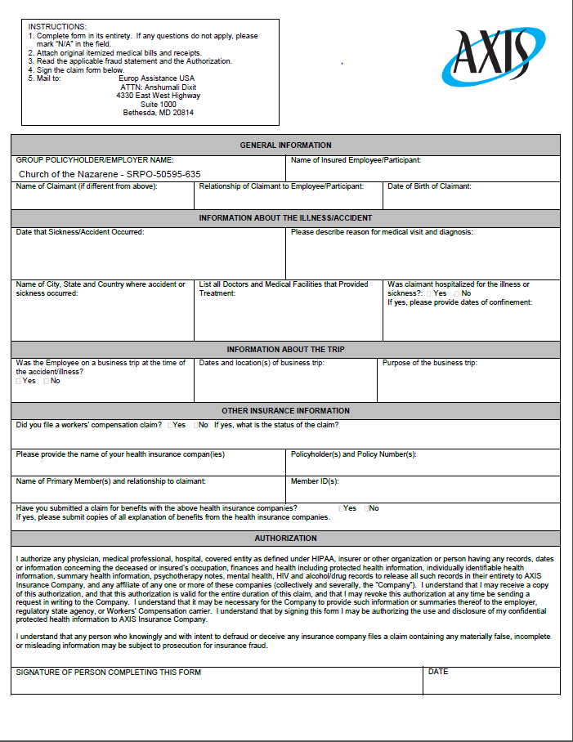

J. Helpful Information
- Index of Acronyms - These acronyms are commonly used throughout the handbook:

CCO | Cross-Cultural Orientation
EMF | Exploring Mission Form
FIF | Financial Information Form
FSC | Field Strategy Coordinator
GMC | Global Ministry Center
GTS | Global Treasury Services
PRF | Personnel Request Form
RD | Regional Director
RPC | Regional Personnel Coordinator

- Mobilization Contacts - This is a helpful list of contact information:

Global Ministry Center
17001 Prairie Star Parkway
Lenexa, KS 66220
913-577-0500

Mobilization Personnel
Greg Taylor, ext. 2959
gtaylor@nazarene.org

Duane Baty, ext. 2961
dbaty@nazarene.org

Beth Heath, ext. 2962
bheath@nazarene.org

Hope Owens, ext. 2963
howens@nazarene.org

Download Forms online
www.missioncorps.org – Resources

Mail contributions to
Church of the Nazarene
P.O. Box 843116
Kansas City, MO 64184

On contribution checks include
(Country of Service, Name, “Mission Corps”)

Insurance Contact after accident

AXIS
001.609.375.9190 (Call Collect)
and

Mobilization Office
913-577-0500 (business hours)
816-699-5420 (non-business hours)

International Calling Code
011

